Parkgate Primary School  APPENDIX TO MATHS POLICY  WRITTEN and MENTAL CALCULATIONS POLICY | 

The aims of the National Curriculum (2014) are that children will become fluent in the fundamentals of mathematics, be able to reason mathematically and be able to solve problems. This policy contains the key pencil and paper calculation procedures that are to be taught throughout the school. It has been written to ensure consistency and progression throughout the school.

At Parkgate a considerable emphasis is placed on teaching mental calculation strategies alongside written methods. Informal written recording should take place regularly and is an important part of learning and understanding. More formal written methods should follow only when the child is able to use a wide range of mental calculation strategies.

Age Stage Expectations
The calculation policy (based on a policy from St. Andrew’s CE Primary School, Weston) is organised according to age stage expectations as set out in the National Curriculum 2014, however it is vital that pupils are taught according to the stage that they are currently working at, being moved onto the next stage as soon as they are ready, or working at a lower stage until they are secure enough to move on.

Providing a context for calculation:
It is important that any type of calculation is given a real life context or problem solving approach to help build children’s understanding of the purpose of calculation, and to help them recognise when to use certain operations and methods when faced with problems. This must be a priority within calculation lessons.

Reasons for teaching mental calculation strategies
- The ability to calculate mentally in your head is an important part of mathematics. It is also an essential part of coping with society’s demands and managing everyday situations.

Reasons for using written methods
- To aid mental calculation by writing down some of the numbers and answers involved
- To make clear a mental procedure for the pupil
- To help communicate methods and solutions
- To provide a record of work to be done
- To aid calculation when the problem is too difficult to be done mentally
- To develop and refine a set of rules for calculation

The long-term aim is for children to be able to select an efficient calculation method of their choice that is appropriate for a given task. They should do this by always asking themselves:

- Can I do this in my head?
- Can I do this in my head using drawings or jottings?
- Do I need to use a written method?

MENTAL CALCULATION

6 aspects of mental calculation
Mental calculation is more than just recalling number facts, although this is an important skill which helps children concentrate on their calculations, the problems and the methods involved. At Parkgate we cover the 6 aspects of maths that involve mental calculation:

- Recalling facts
- Applying facts
- Hypothesising or predicting
- Designing and comparing procedures
- Interpreting results
- Applying reasoning

Hands-on learning
Calculating mentally often involves ‘seeing’ objects, images or quantities that help children manage the process. Hands-on learning is therefore essential. At Parkgate teachers provide suitable equipment for children to manipulate and explore how and why a calculation strategy works, in order to help them describe and visualise or ‘see’ the method working.

Planning for progression
All teachers review, consolidate and build on children’s developing mental calculation skills throughout Key Stages 1 and 2. Discrete units for teaching mental methods are included in the whole school planning over view. Mental calculations are taught using the strategies and progression outlined in ‘Teaching Children to Calculate Mentally’ DFE 2010. An electronic copy of this document is held on the teacher area of the server under ‘New Curriculum’, ‘Maths’.

C Watkins February 2020

Review Date: February 2022
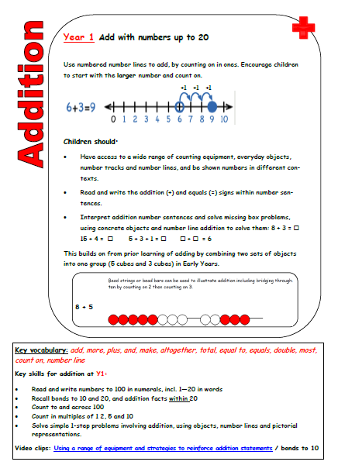
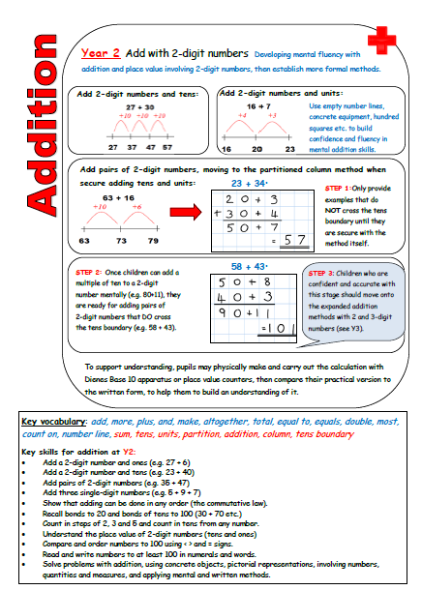
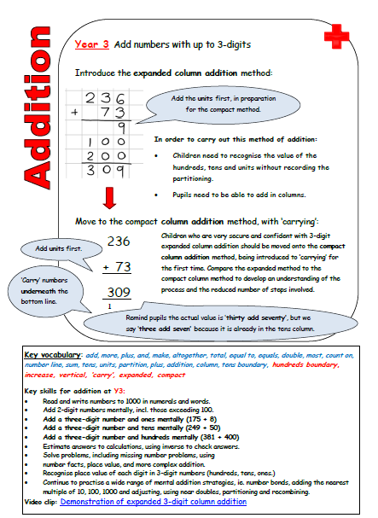
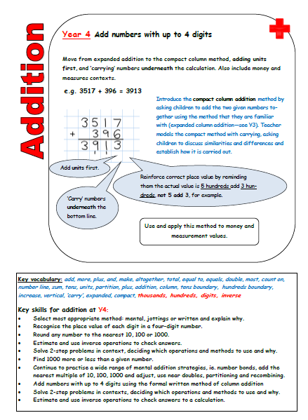
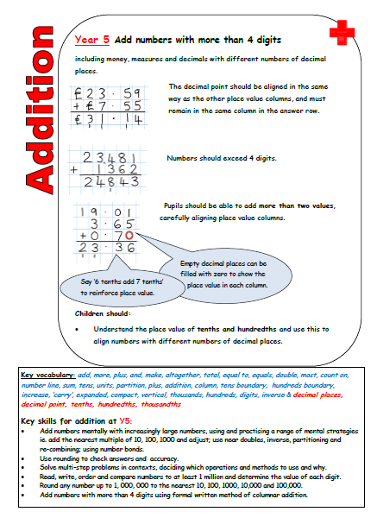
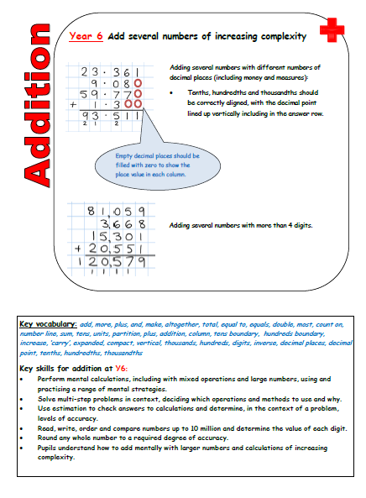
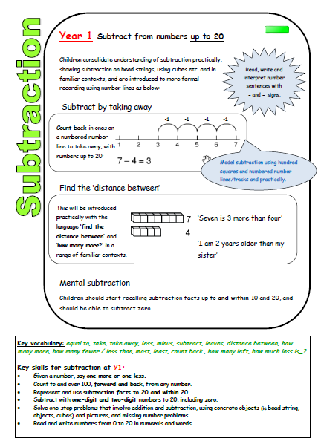
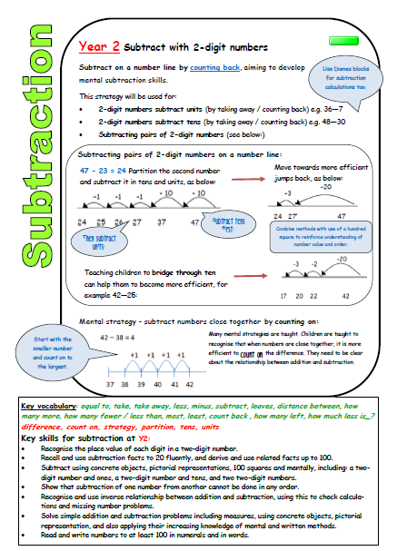
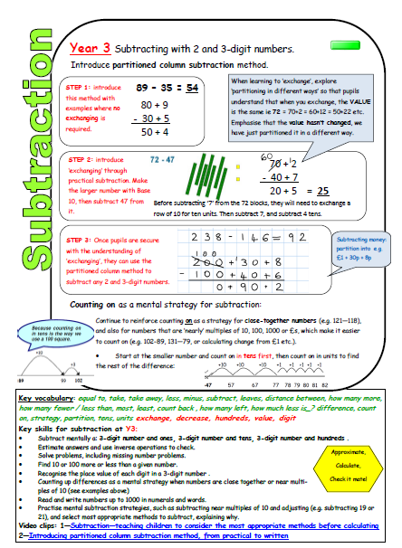
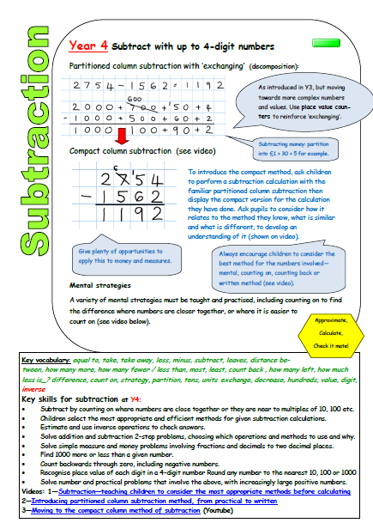
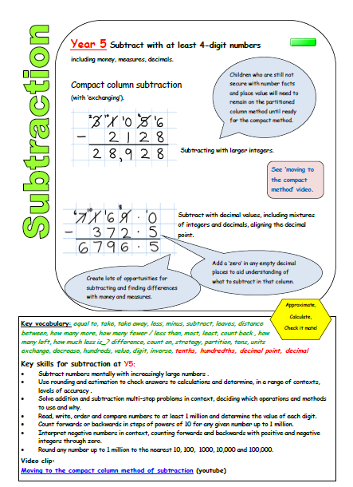
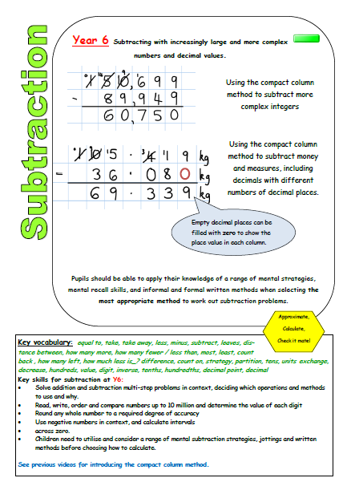
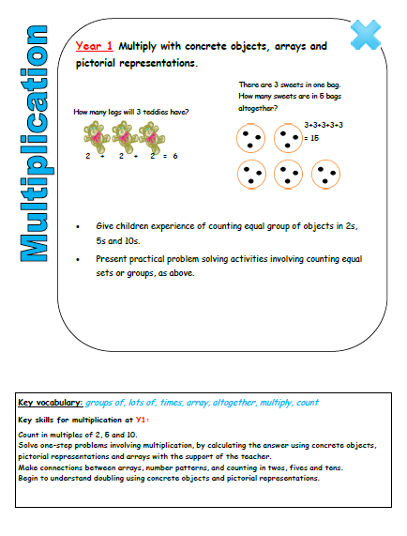
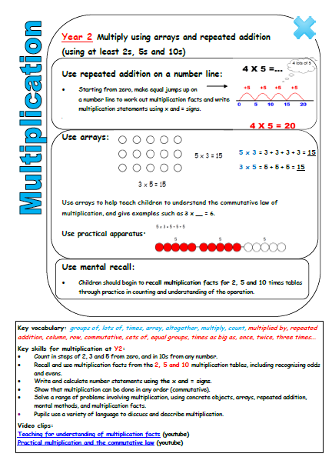
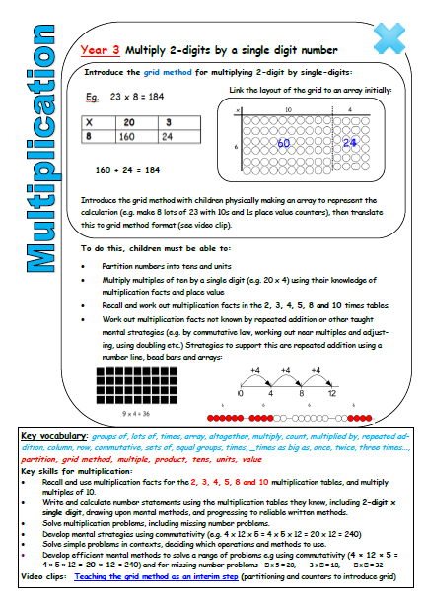
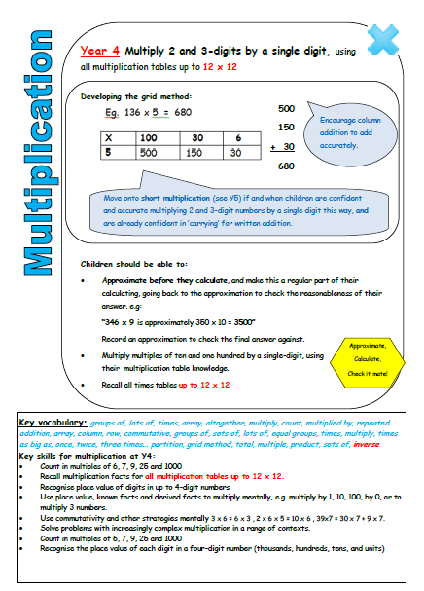
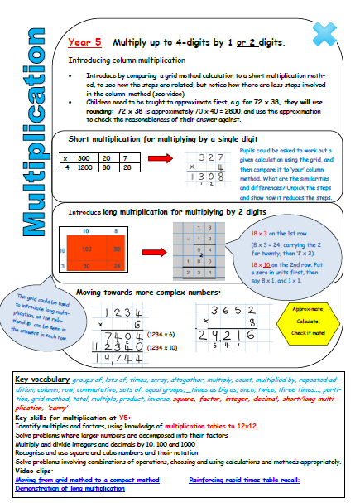
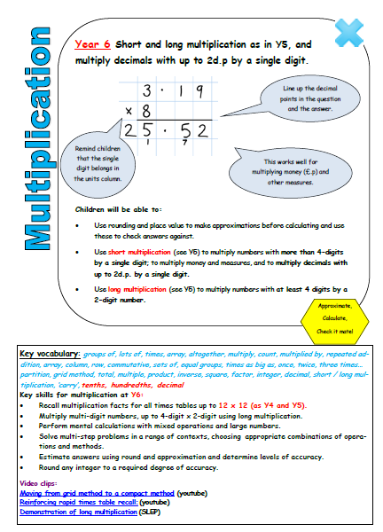
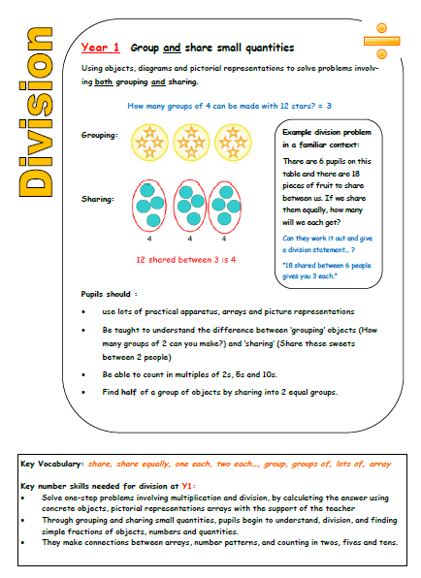
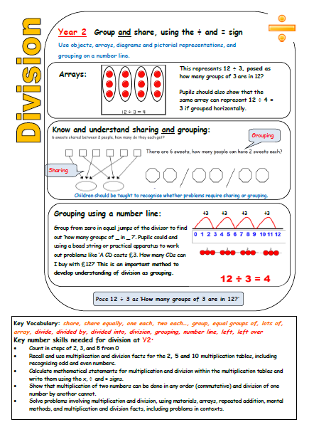
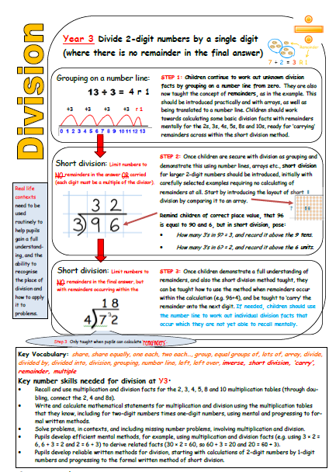
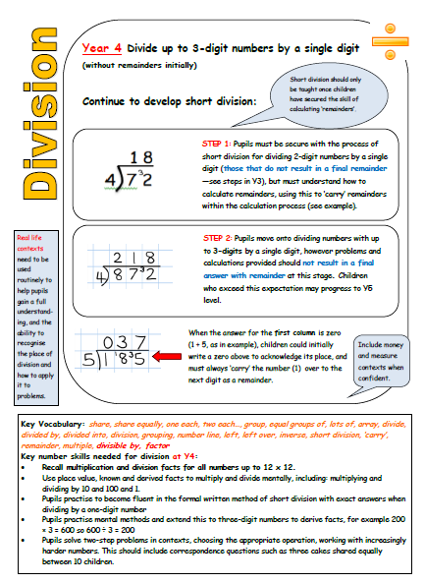
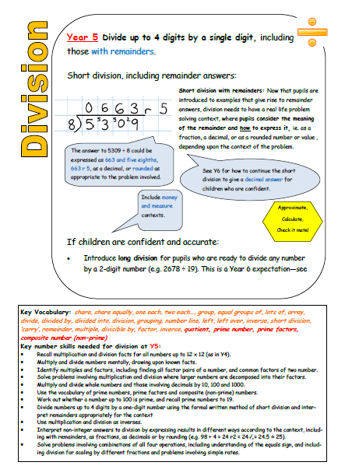
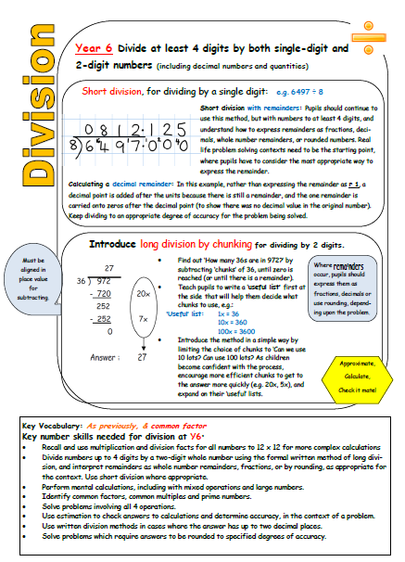
972 by

